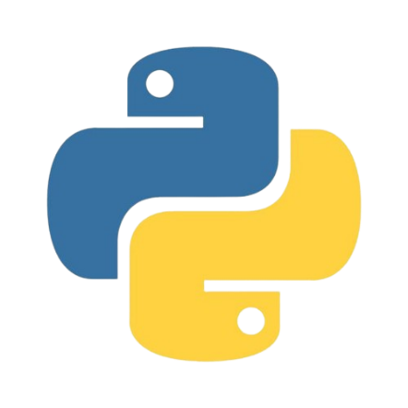

**Congratulations**

**Certificate**

**of Completion**

**has completed the 4-hour Python Programming Introduction Course**

**August 8th and 9th 2024**